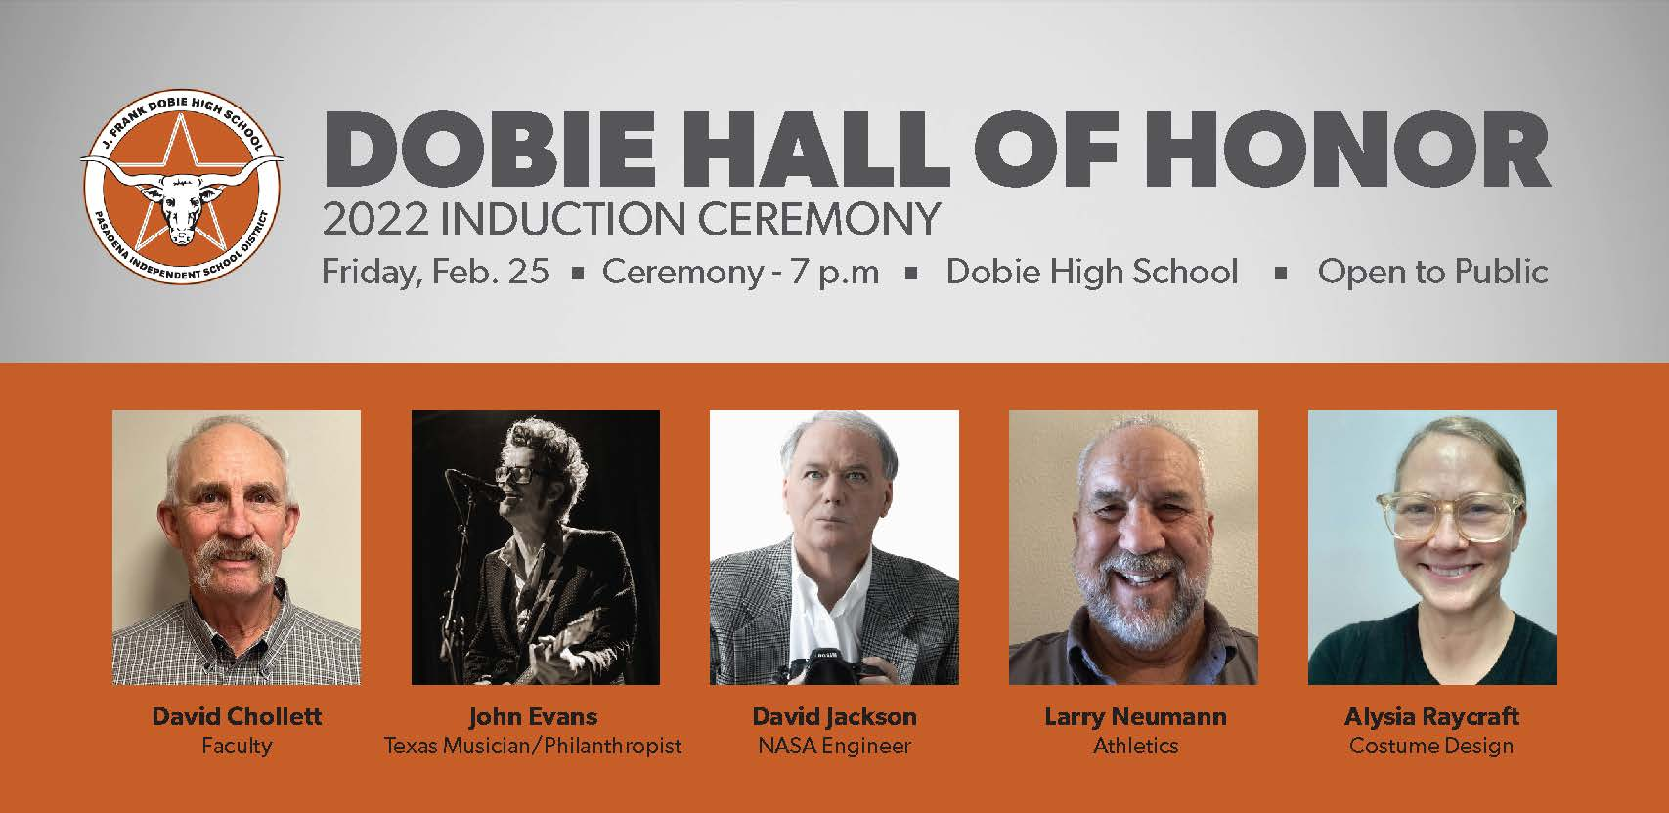
LARRY NEUMANN c/o 1970
Larry Neumann was a football standout and member of FFA at Dobie High, earning a football scholarship to attend Kilgore College and a Pasadena Rodeo scholarship. He returned to his alma mater in 1974 to begin his coaching career, where he remained for seven years before coaching the Nederland High Bulldogs. Neumann’s coaching record was 186-93-1, with 20 playoff games and the 2001 state semi-finals. After 24 years at Nederland High, he retired as Southeast Texas' longest-tenured head coach. Neumann was recognized for making a positive impact in the Nederland community and for his outstanding coaching career during the Southeast Texas Coaches Association’s 2018 Hall of Honor.
DAVID JACKSON c/o 1981
David Jackson graduated from the University of Houston with honors in Mechanical Engineering in 1986. He worked for NASA for 34 years, starting after the Challenger accident with the Safety and Mission Assurance team. He was instrumental in the Hubble Space Telescope Repair Mission-1. He spent a year’s detail at NASA Headquarters in DC, where he served as technical assistant to the NASA International Space Station (ISS) program director. As the Extravehicular Vehicle Activity (EVA) project manager, Jackson enjoyed developing all the ISS EVA hardware needed to build and support the Space Station. He completed his career with NASA as the ISS Vehicle Office International Partner logistics and maintenance lead. This assignment allowed him to negotiate international agreements with all the ISS international partners, including establishing relationships and traveling regularly to Moscow, Torino and Tokyo. He has received numerous awards from NASA, including the Silver Achievement Medal, the Director's Commendation Award, and the Exceptional Achievement Medal. Jackson is also active in many charities. He was president of Trinity Foster Care Group, chairman and major contributor to the Trinity Foster Care Gala. He also served as the organization’s Christmas Toy Drive Director for approximately 15 years. He has been a member of the Houston Livestock Show and Rodeo for 24 years. Beyond his charitable contributions, he is also a photographer and avid supporter of musicians and the arts. His future goals include ways to better support education, journalism and climate change.
ALYSIA RAYCRAFT c/o 1986
Alysia Raycraft is an artist and educator who now resides in Austin, TX. After graduating from Dobie High School in 1986, she attended the University of Texas at Austin and obtained a bachelor’s degree in Fine Arts. She moved to New York to study textile surface design at the Fashion Institute of Technology. Raycraft started her career in fashion, theatre costume design, earning her master’s of fine arts from New York University’s Tisch School of the Arts as well as an Artist in Residency at the New York City Ballet. She later decided to focus on a career in filmmaking while teaching in between projects at Fine Arts museums, charter schools and public schools. Toward the end of her film and television career, Raycraft became focused on arts integration in primary and secondary education. She will be graduating with her master’s of science in April of 2022. Raycraft was notably the make-up and wardrobe supervisor for Blue Man Group, New York and maintained the puppets for “The Lion King”- New York Broadway production. She was also the costume designer for Seasons 5-9 of the NBC Series, “The Office.”
JOHN EVANS c/o 1986
A star quarterback and letterman in track and basketball, Evans went on to become a four-year letterwinner on the Lamar University football team, graduating as the top passing quarterback in the school’s history. He set the LU single-season passing mark by throwing for 2,901 yards in 1989 and the career passing mark with 6,347 yards. As a senior, Evans posted the school’s top three single-game total offense outputs with 421 yards against the University of Texas El Paso, 405 yards against Angelo State University and 396 yards against McNeese State University. Evans was one of two division I-AA quarterbacks selected to play against the division I-A all-stars in the Martin Luther King Classic, following the 1989 season. He was inducted into the Cardinal Hall of Honor in 2001. After the shutdown of Lamar football in 1989, Evans pursued his interest in music. His decorated career has earned him many awards and accolades, including six-time Best Male Vocalist, four-time Best Songwriter, two-time Musician of the Year in the Houston Press. He has a successful career as a music producer, camp counselor and mentor to up and coming young artists. His music has been featured in movies and TV, including Country Strong and on the series finale of the television show Friday Night Lights. One of John’s greatest thrills was appearing with his good friend, Hayes Carll, on the Tonight Show, performing an original song. Another experience that was “a real hoot” was when HGTV’s Junk Gypsies redecorated his living room. His seventh album was a tribute to his daughter, Abigail, who passed away in 2013, at the age of 20, from a rare and debilitating congenital skin disease. Her story was the subject of the indie film Butterfly Girl. Today, Evans continues to play music, often performing for charity. His most recent endeavor was Honkytonk for Hope, an organization that assists local community members facing life changes due to catastrophic medical issues, offering financial assistance to families in need.

DAVID CHOLLETT – FACULTY/STAFF
David Chollet has been making a positive impact on students since 1981. He taught U.S. history and U.S. government while coaching in several capacities as the head cross country coach (nine years); assistant and then head track and field coach (29 years); assistant football coach (26 years), and assistant baseball coach (eight years). Under his leadership, one student qualified for the state championship in the 800 meters. Beyond his coaching career, he was held in the highest regard by students and staff for his stellar work ethic and caring spirit. “He commanded and expected our best effort in the classroom and in athletic competitions. It was so easy to give your best effort for a teacher and coach that was clearly giving us his best effort every day,” said one of his former student’s, Carey Sink (Class of 1990).

